Karin Hurt: CEO, Let’s Grow Leaders
Highly Interactive Keynotes, Practical Takeaways

When you hire a leadership keynote speaker, it’s not enough to leave everyone energized and feeling good – you need inspiration and practical ideas that create lasting change. What differentiates Karin Hurt’s keynotes is high-energy audience engagement and practical application. Your audience will walk away with specific tools they can use to make a difference right away.

Courageous Cultures: How to Help Your Team Solve Problems Faster and Surface Remarkable Ideas

Format: 60-90 Minute Interactive Keynote (or longer workshop)

Practical ways to inspire employee engagement and accelerate team performance.

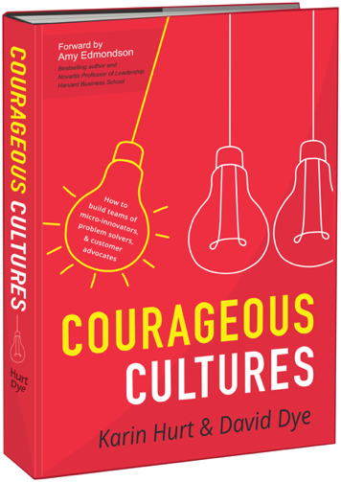
Based on ground-breaking new research in innovation and problem-solving, you’ll learn what leaders like you are doing to build more creative and solutions-oriented teams. Teams who don’t just bring you more ideas, but practical ideas you can use to make work, work better.

You’ll explore the root causes of FOSU (fear of speaking up) and ways to turn your team’s fears and frustration into practical innovation. You’ll learn easy-to-use tools and techniques to empower solutions-thinking and customer-focused problem solving; how to respond to wacky ideas without crushing your team’s hearts and spirits; and techniques to encourage courage and deeper dialogue up, down, and sideways.
Your audience will leave with:
- Inspiration to be a role model of innovation and problem solving.
- Researched-based, practical techniques to inspire more confidence and competence sharing ideas.
- Tools to lead make it easy for team members to share practical, remarkable ideas
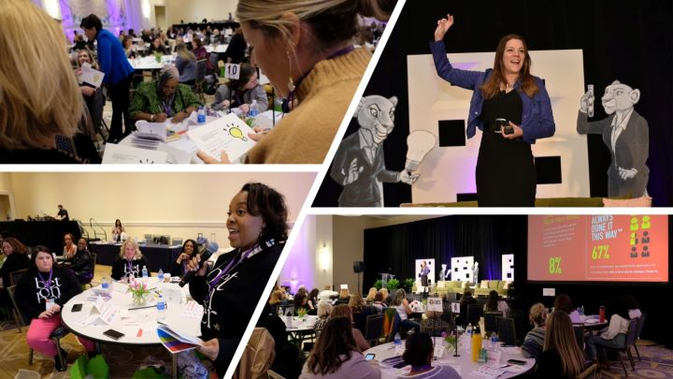
- Techniques to respond to ideas (even if you can’t use them) in a way that inspires future innovation and problem solving
Based on our award-winning book Courageous Cultures: Building Teams of Micro-Innovators, Problem Solvers and Customer Advocates (Harper Collins 2020)

We also have a very popular half-day to full-day program where your team applies our Courageous Cultures tools and techniques to strategic business challenges.

Courageous Leadership: Practical Ways to Be More Daring
(Premiered at 2023 ATD: Association for Talent Development Global Conference)

Practical ways to have more confidence, influence, and impact.

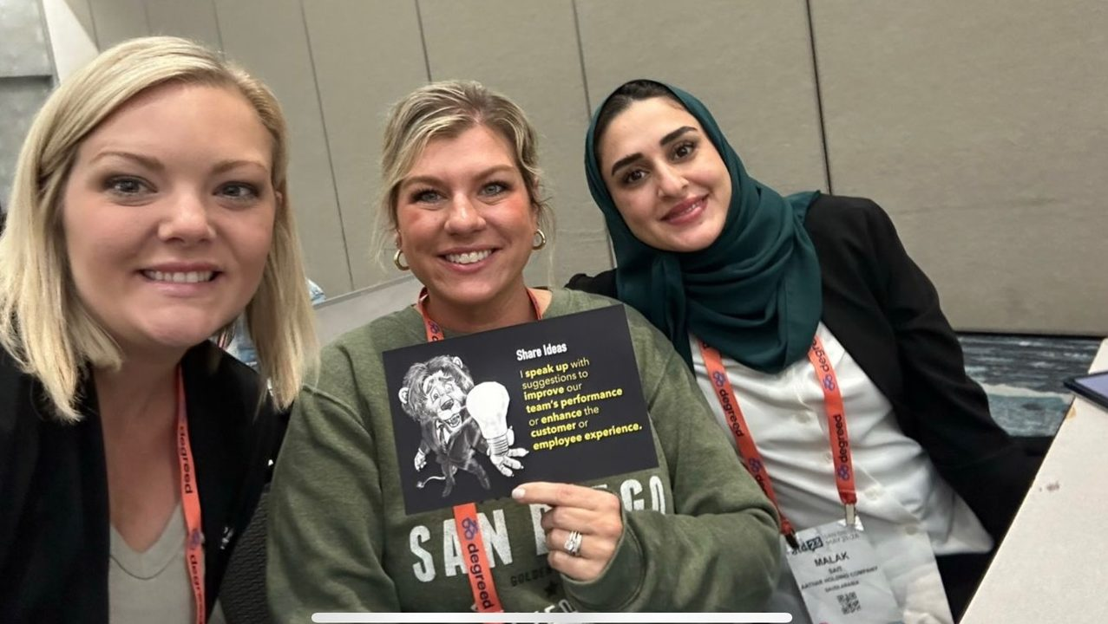
As a leader, you're barraged with problems every day, and sometimes it's easier to take the path of least resistance. You don't speak up because it might rock the boat. You procrastinate on a decision or don't try that new idea because you're afraid of failure. Or, you don't invite feedback because you might not like what you hear.

In these moments, you're missing opportunities, you're wasting money, and you're eroding your team members' trust.

Building your reputation as a courageous leader doesn't necessarily mean making big, bold, game-changing moves. It happens every day, little by little, as you own your team members' strengths, speak up, stand out, and dare to take appropriate risks.
The audience will leave with:

- Inspiration to own their strengths and contribute at a deeper level.
- Practical tools and techniques to present their ideas with confidence.
- Techniques to prepare for and hold difficult conversations up, down, and sideways, including our I.N.S.P.I.R.E. approach to performance management.
- Tools for gathering and responding to feedback.

Based on our award-winning book Courageous Cultures: Building Teams of Micro-Innovators, Problem Solvers and Customer Advocates (Harper Collins 2020)

Navigating Workplace Conflict: How to Have More Influence, Less Drama, and Better Collaboration

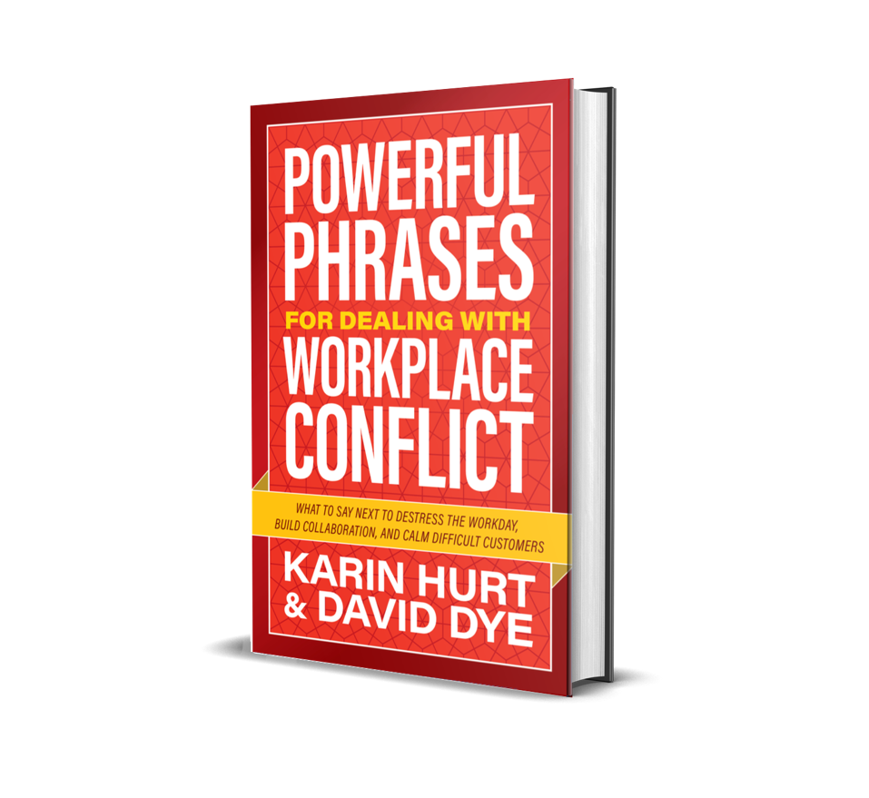
Master any workplace conflict with confidence and ease, have less drama, better results, and thrive at work.

When there are problems to solve, and people who care (and there are so many things to care about) you’ll face conflict. And if you want to have more success, influence, and joy in your work, you’ve got to navigate it well. But conflict is hard. You weren’t born knowing the perfect words to say when you’re angry, dealing with a jerk, or when someone calls your game-changing idea “stupid.”

This highly experiential program is based on findings from our expansive World Workplace Conflict and Collaboration research (5000 participants in 45 countries) and our new book, Powerful Phrases for Dealing with Workplace Conflict (Harper Collins, May 2024).

You’ll leave with the courage, confidence, and competence to navigate even the trickiest conflict scenarios and build better, lasting collaboration.

You'll learn:
- Researched-based reasons why conflict is so hard now-- and inspiration to have the conversation you would rather avoid.
- The 4 Cs of more productive conflict and how to apply them to even the most challenging scenarios.
- 12 Powerful Phrases for navigating any workplace conflict.
- Practical techniques and tools to foster deeper trust and collaboration.

Note: I also have a version of this program with a focus on dealing with difficult people at work.

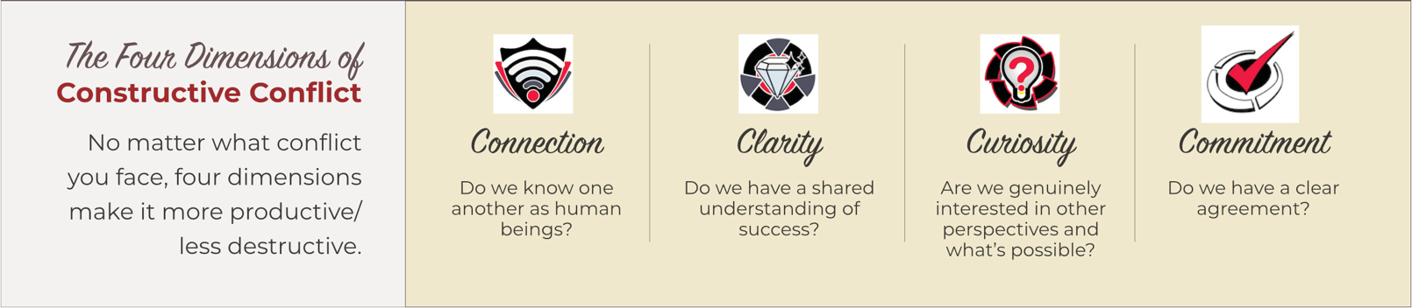

Respectful Rebellion: How to Say No for a Bigger Yes

Practical communication techniques to make a bigger impact.
Every time you or your team says “yes” to something or someone, you’re saying “no” to something or someone else. Balancing this challenging cocktail of conflicting priorities and demands on limited resources can get tricky. You want to be viewed as a highly collaborative team player AND a results-focused leader making an impact on your organization's most strategic priorities.
In this highly interactive keynote, you’ll learn practical tools and techniques to say “no” with poise, assurance, and tact, positioning you as a leader who effectively balances demands with overarching organizational goals.

You’ll gain confidence and courage by focusing on your bigger “yes,” propelling innovative solutions and fostering a collaborative environment.

The audience will leave with:
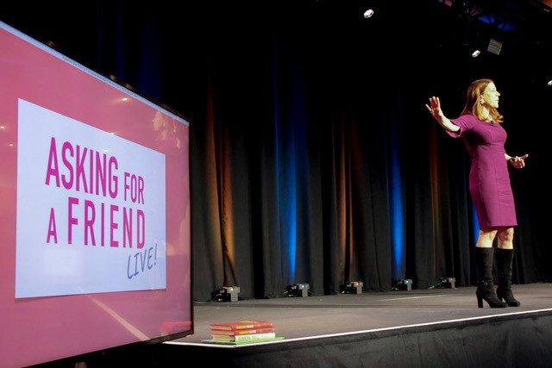
- Practical tools and techniques to gain better clarity and communicate what matters most
- Communication strategies to navigate competing priorities and conflicting goals
- Powerful phrases to communicate in even the most difficult workplace scenarios

Based on our new book, Powerful Phrases for Dealing with Workplace Conflict (Harper Collins, May 2024).

Karin Hurt, CEO Let’s Grow Leaders

Karin Hurt helps human-centered leaders find clarity in uncertainty, drive innovation, and achieve breakthrough results.

She’s the Founder and CEO of Let’s Grow Leaders, a global leadership development firm known for practical tools and techniques for human-centered leaders.

A former Verizon Wireless executive with more than two decades of experience in sales, customer service, and human resources, Karin is known for growing courageous leaders, building great cultures, and inspiring high-performance teams.

Since 2013, Karin and her husband, David have grown tens of thousands of leaders on every continent (except Antarctica) with their leadership development programs and keynotes. They also provide clean water to the people of Cambodia through their Winning Wells philanthropic initiative.

Karin is an award-winning author of five books, including:

Powerful Phrases for Dealing with Workplace Conflict: What to Say Next to Destress the Workday, Build Collaboration and Calm Difficult Customers (May 2024)

Courageous Cultures: How to Build Teams of Micro-Innovators, Problem Solvers, and Customer Advocates

She is the host of the popular LinkedIn show, Asking for a Friend and is the advice column, Courage Coach. And she was recently named by Inc. Magazine as a Top 100 Great Leadership Speaker.

